ANIMAL SLAM
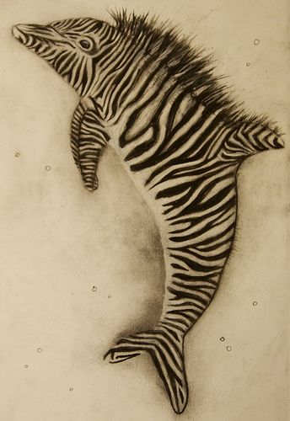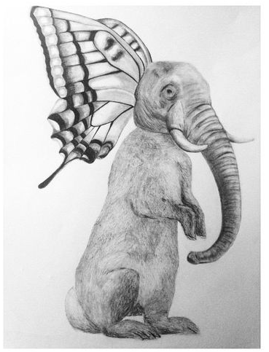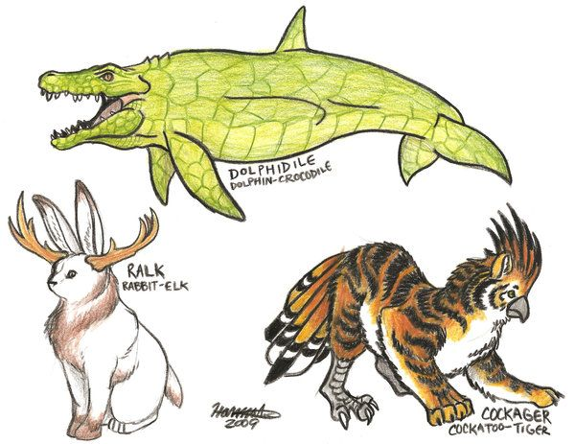
What if 2 animals got together to create a new species?
What would that look like?
Would it be half one animal and half another animal or would it combine some traits of one onto the body of another?

Your artistic mission is to create a new Animal species.
Combine 2 or MORE animals into one new animal.

- The materials are up to you; draw, paint, pen and ink, sculpt, collage.
- Use whatever you have on hand and are comfortable creating with.
- It should look like you spent a good amount of time on it, I can tell!!
- Take a picture and upload it to Classroom* when you are done
- List what animals you combined in the private comments section

If you can not upload to Classroom try to put it in a doc, then attach that in Classroom
OR
Email me the picture

Can’t wait to see what you create!!

